1-Laboratoriya
Mavzu: AJAX so‘rovlari yuborish va javobni ishlash.
Kirish:
AJAX — bu veb-sahifani butunlay yangilamasdan (refresh qilmasdan), uning ma'lum bir qismini serverdan olingan ma'lumotlar asosida yangilash imkonini beruvchi texnologiyalar to'plamidir. Bu foydalanuvchi tajribasini (UX) sezilarli darajada yaxshilaydi, chunki veb-ilova tezroq va interaktivroq ishlaydi.
Nazariy qism:
AJAX bitta texnologiya emas, balki bir nechta texnologiyalarning kombinatsiyasidir:
- HTML va CSS: Ma'lumotlarni vizual ko'rsatish uchun.
- DOM (Document Object Model): Sahifa tarkibini dinamik o'zgartirish uchun.
- XMLHttpRequest yoki Fetch API: Server bilan asinxron ma'lumot almashish uchun.
- JSON yoki XML: Ma'lumotlar formati sifatida (hozirda JSON standarti keng qo'llaniladi).
1. Asinxronlik tushunchasi
Odatdagi (sinxron) so'rovlarda brauzer serverdan javob kelguncha "qotib" qoladi. AJAX so'rovlarida esa brauzer so'rovni fonda (background) yuboradi va foydalanuvchi sahifa bilan ishlashni davom ettirishi mumkin. Javob kelganida, maxsus "callback" funksiyasi ishga tushadi.
2. AJAX so'rovi yuborish usullari
Bugungi kunda AJAX so'rovlarini amalga oshirishning uchta asosiy usuli mavjud:
Usul | Tavsif | Holati
XMLHttpRequest (XHR) | Klassik usul. Ob'ektga asoslangan, biroz murakkab sintaksisga ega. | Eski, lekin hali ham ishlatiladi.
Fetch API | Zamonaviy va sodda usul. Promise (va'da) tushunchasiga asoslangan. | Standart tavsiya.
Axios (Kutubxona) | Tashqi kutubxona bo'lib, xatolarni boshqarish va JSON'ni avtomatik qayta ishlashda qulay. | Juda mashhur.
3. HTTP metodlari
AJAX so'rovlari davomida serverga nima qilmoqchi ekanligimizni bildirish uchun quyidagi metodlardan foydalanamiz:
- GET: Ma'lumotlarni olish uchun.
- POST: Yangi ma'lumot yuborish (masalan, ro'yxatdan o'tish).
- PUT/PATCH: Mavjud ma'lumotni tahrirlash.
- DELETE: Ma'lumotni o'chirish.
4. Javob statuslari (HTTP Status Codes)
Serverdan kelgan javobni qayta ishlashda status kodlari muhim:
- 200 OK: So'rov muvaffaqiyatli bajarildi.
- 404 Not Found: Resurs topilmadi.
500 Internal Server Error: Serverda xatolik

Ishni bajarish tartibi,
Visual coda fayl yaratdim va shularni ketma ket bajardim:

Amaliy qism:
Bu mening o’zimni mustaqil ishlab yurgan saytim bo’ladi men endi unga mana shu mavzuga doir bolgan AJAX texnologiyalar to'plamidan foydalanib yangilik qo’shaman.

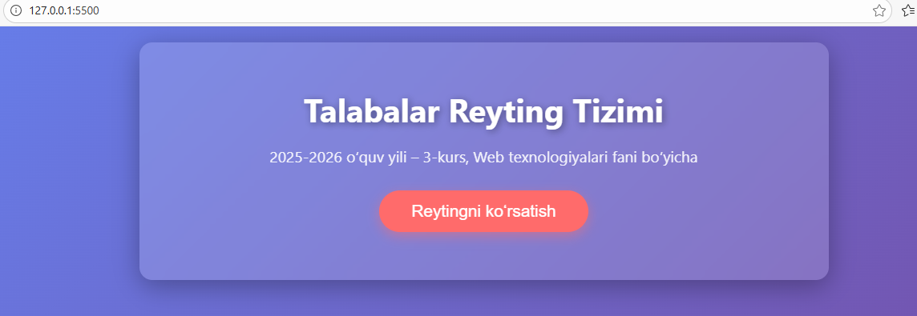

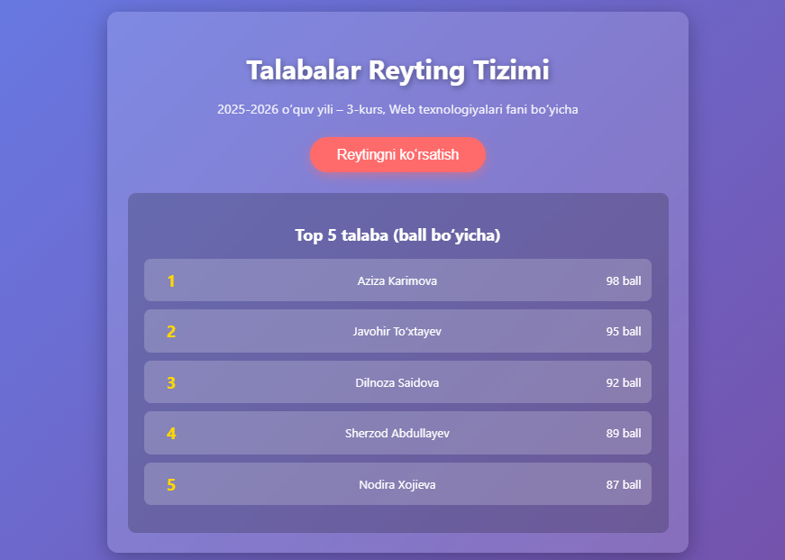
1-qadam: index.html faylimdagi .live-clock dividan keyin quyidagicha kod qo'shdim:
<!DOCTYPE html>
<html lang="uz">
<head>
<meta charset="UTF-8">
<meta name="viewport" content="width=device-width, initial-scale=1.0">
<title>Talabalar Reyting Tizimi</title>
<style>
body {
font-family: 'Segoe UI', Tahoma, Geneva, Verdana, sans-serif;
background: linear-gradient(135deg, #667eea, #764ba2);
color: #fff;
margin: 0;
padding: 20px;
min-height: 100vh;
}
.container {
max-width: 800px;
margin: 0 auto;
background: rgba(255,255,255,0.15);
backdrop-filter: blur(10px);
border-radius: 16px;
padding: 30px;
box-shadow: 0 8px 32px rgba(0,0,0,0.3);
}
h1 {
text-align: center;
margin-bottom: 10px;
font-size: 2.5em;
text-shadow: 2px 2px 10px rgba(0,0,0,0.4);
}
.subtitle {
text-align: center;
font-size: 1.2em;
margin-bottom: 30px;
opacity: 0.9;
}
button {
display: block;
margin: 30px auto;
padding: 14px 40px;
font-size: 1.3em;
background: #ff6b6b;
color: white;
border: none;
border-radius: 50px;
cursor: pointer;
transition: all 0.3s;
box-shadow: 0 5px 15px rgba(255,107,107,0.5);
}
button:hover {
background: #ff4757;
transform: translateY(-3px);
box-shadow: 0 10px 25px rgba(255,107,107,0.6);
}
#result {
margin-top: 30px;
background: rgba(0,0,0,0.2);
padding: 25px;
border-radius: 12px;
display: none;
}
ul {
list-style: none;
padding: 0;
}
li {
background: rgba(255,255,255,0.2);
margin: 12px 0;
padding: 15px;
border-radius: 10px;
font-size: 1.1em;
display: flex;
justify-content: space-between;
align-items: center;
}
.rank {
font-weight: bold;
font-size: 1.4em;
min-width: 50px;
text-align: center;
color: #ffd700;
}
</style>
</head>
<body>

<div class="container">
<h1>Talabalar Reyting Tizimi</h1>
<p class="subtitle">2025-2026 o‘quv yili – 3-kurs, Web texnologiyalari fani bo‘yicha</p>

<button onclick="loadStudents()">Reytingni ko‘rsatish</button>

<div id="result">
<h2 style="text-align:center; margin-bottom:20px;">Top 5 talaba (ball bo‘yicha)</h2>
<ul id="studentList"></ul>
</div>
</div>

<script src="script.js"></script>
</body>
</html>

2-qadam: Dizayn berish (style.css)
<!DOCTYPE html>
<html lang="uz">
<head>
<meta charset="UTF-8">
<meta name="viewport" content="width=device-width, initial-scale=1.0">
<title>Talabalar Reyting Tizimi</title>
</head>
<body>

<div>
<h1>Talabalar Reyting Tizimi</h1>
<p>2025-2026 o‘quv yili – 3-kurs, Web texnologiyalari fani bo‘yicha</p>

<button onclick="loadStudents()">Reytingni ko‘rsatish</button>

<div id="result" style="display:none;">
<h2>Top 5 talaba (ball bo‘yicha)</h2>
<ul id="studentList"></ul>
</div>
</div>

<script src="script.js"></script>
</body>
</html>
3-qadam: AJAX (Fetch) orqali ma'lumot olish (script.js)
function loadStudents() {
const resultDiv = document.getElementById('result');
const list = document.getElementById('studentList');

// Oldingi natijalarni tozalash
list.innerHTML = '';
resultDiv.style.display = 'block';

// AJAX so'rovi (fetch ishlatamiz - zamonaviy usul)
fetch('data.json')
.then(response => {
if (!response.ok) throw new Error('Fayl topilmadi yoki xato!');
return response.json();
})
.then(data => {
// Ball bo'yicha saralash va top 5 ni olish
const sorted = data.students.sort((a, b) => b.ball - a.ball).slice(0, 5);

sorted.forEach((student, index) => {
const li = document.createElement('li');
li.innerHTML = `
<span class="rank">${index + 1}</span>
<span>${student.ism} ${student.familiya}</span>
<span>${student.ball} ball</span>
`;
list.appendChild(li);
});
})
.catch(error => {
list.innerHTML = `<li style="color:#ff6b6b; text-align:center;">Xato: ${error.message}</li>`;
});
}

Nazariy tushuntirish:
- fetch(): Bu AJAX so'rovini yuborishning eng zamonaviy usuli. U ko'rsatilgan manzildan ma'lumot kelishini "va'da" (Promise) qiladi.
- await: So'rov javobi kelmaguncha keyingi qatordagi kodni to'xtatib turadi (lekin butun saytni qotirmaydi).
- async: Funksiya ichida await ishlatish uchun funksiya "asinxron" deb e'lon qilinishi shart.
- json(): Serverdan kelgan xom ma'lumotni bizga tushunarli JavaScript ob'ekti (massiv) holatiga o'tkazib beradi.

